

Gyanmanjari Institute of Law
Bhavnagar
Report on
INDUSTRIAL VISIT AT SUMITOMO CHEMICALS INDIA LTD.

Date: 15/10/2025
Time: 9:30 AM to 1:00 PM
Location: Ruvapari Road, Bhavnagar.
L.L.B:- SEM- 1
Department | Law
Activity | Industrial visit
No. Of Students | 20
Faculty coordinator |  | Prof. Mohit S. Bhatt  Prof. Reny F. Vyas

Objective:-
An Industrial visit was organized by the Law Department of Gyanmanjarai Innovative University on 15/10/2025 to SUMITOMO CHEMICALS INDIA LTD., Ruvapari Road, Bhavnagar. The objective of the visit was to provide students with practical exposure to industrial operations and to bridge the gap between theoretical knowledge and real-world practices.
About activity:-
The Industrial visit was conducted at the Sumitomo Chemicals India LTD., Ruvapari Road, Bhavnagar on 15/10/2025.The session aimed to strengthen and understand the practical implementation of classroom knowledge. Students observed and learned the workflow of an industrial environment. Students gained insight into the technology, machinery, and processes used. They interacted with industry professionals and HR Professionals Hiten Goswami and Sanjay sharma and understood job roles and responsibilities. Further they explored the safety standards, organizational structure, and quality control measures.

Key Learnings from the Visit::
Students acquainted with Real-time exposure to industrial equipment and processes, Understanding of production line flow and machinery automation. Students got Knowledge about how to register for license under Factories Act, 1948.Further they got awareness about software and tools used in the company for production tracking, data management and Interpersonal and management skills observed among professionals.

The Industrial visit to Sumitomo Chemicals India LTD. was an enriching experience. It provided valuable exposure to the Industrial environment and helped in understanding the practical aspects of various concepts studied in the classroom. The visit fostered learning beyond textbooks and encouraged students to align their skills with industry requirements.

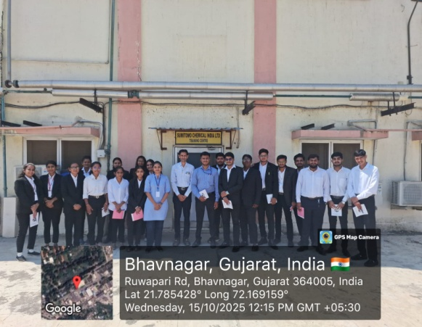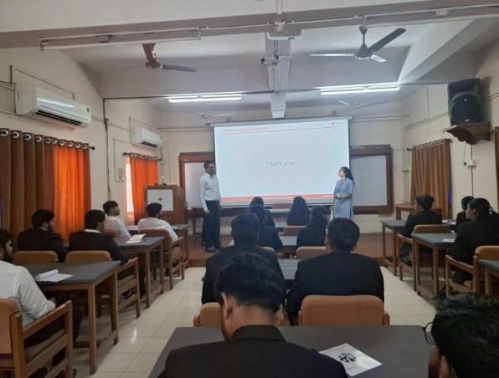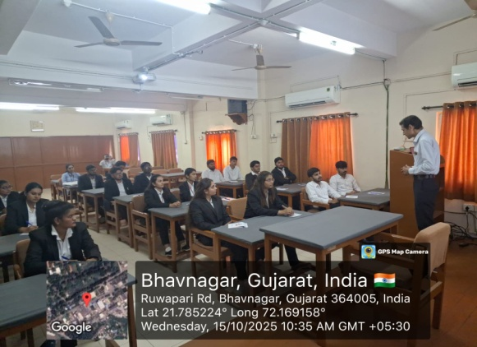 gh 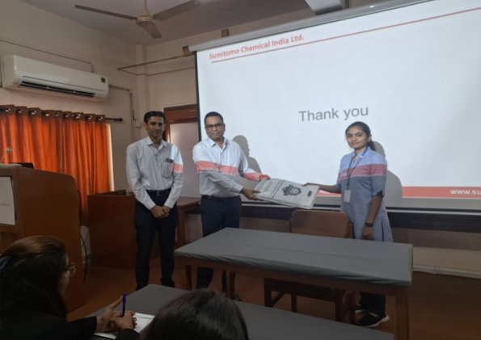

TPA LAW Dept. HOD LAW Dept.

